

Structural Design

(Inside View)

**Vertical corrugation**

Design#:

 103*/*16 

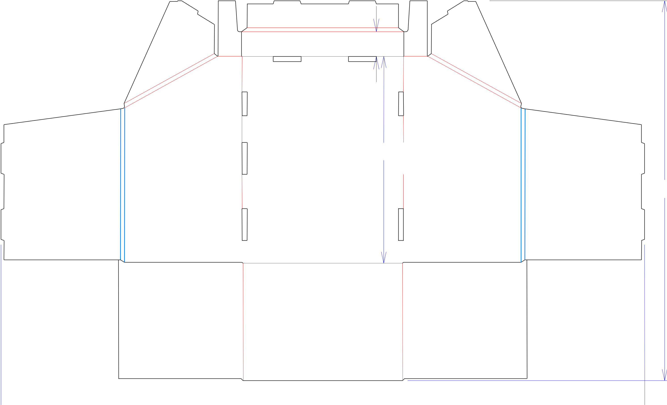

19*/*16

13 

 101*/*8  73*/*8 

 403*/*8 

**130190-01_A**

Customer:

**DeMet's Candy**

Description:

1. **TRY 6/12.8 oz LD GIFT TIN DISPLAY TRAY**

**SINGLE-OUT DRAWING**

Qty/Unit: **1 PER DISPLAY**

Style: **NJDC**

Board: **32 B W (BWK32)**

237*/*8 I.D. : **9+1/2 x 12+3/8 x 7+5/16**

Area of Blank - Waste : **4.89 sq. ft.**

Waste on Blank : **26.92%**

Finished Piece Weight: **0.50 lbs./228.60g**

Over-all Blank: **23+7/8 x 40+3/8**

**D/C from INSIDE**

Notes:

**MUST BE TRIED WITH FULL PRODUCT ~ Converted to "M" BR 7/10/14**

Revision Info: **[A] 09/04/2013**

**Remove back roll over and add 1/8" to W - BR**

Designer: **LEGACY**

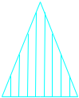

Cut Crease Crease with Matrix Cut Crease Half Knife Cut Tear Tape Perforation



Designright and Copyright of DS Smith Corrugated Packaging Ltd. This technical Specification is subject to Manufacturing tolerances. Drawing dimensions shown are crease to crease. Date printed: 03/01/2021